Bretherton Energy
Fifth Bi-Monthly Update – June 2023

- Introduction

GA are circulating this fifth bi-monthly update to all those who attended the launch of “Our Mutual Journey to Net Zero” at Plocks Farm on 20th May 2022, to keep you fully informed as to what is happening.

This is an update note produced by GA, and confirms the position as GA understands it to be, and does not purport to be the views of any other party.

2. Exhibitions

The Bretherton Energy Partnership has attended two exhibitions to explain the Asland Walks Energy Park proposal, and to seek support from the local Community.

- Celebrating Innovation – Chorley Council
Wednesday 19th April 2023 at Botany Bay
- Lancashire Community Climate Action Forum
Wednesday 17th May 2023 at Edge Hill University

Both events allowed discussion on goals and challenges. The sharing of ideas on developing collaboration and mutual support, and meeting others working in different aspects of climate action and community engagement.

It is hoped to continue to do more engagement with the local community over the coming year.

- Tree Planting and Grassland Access

Following a wet autumn, and dry winter, the tree planting at the southern end of Asland Walks Energy Park was completed as planned. Further additional tree planting will continue around the remainder of the site during the winter of 2023/24. An 8m wide grassland access, has been sewn with grass along the edge of the river and canal. This will establish a wider access area, and help residents envisage the long-term management of this area.

- Lidar – Wind Direction and Wind Speed Monitor

The initial results of the wind speed monitoring are shown below, indicating the mean wind speed in metres per second at the various heights.

The graph shows that at the proposed hub height of 131m, the wind speed is on average 8.1 metres per second (m/s) or 18.1 mph. The wind speed needs to be at least 6 m/s to be viable. Any site with an average wind speed of 7 m/s or above would be considered excellent for a wind turbine. It should be noted that monitoring began on the 4th January 2023 and data analysed is from then until present, therefore average wind speed data may change as we go forward.

The amount of power generated by a wind turbine is proportional to the cube of the wind speed. This means that increasing the average wind speed from 6 m/s to 7 m/s results in 60% more power from the same turbine and an increase in annual energy production of 36%.

For more information on wind power please follow the link below;

https://www.renewablesfirst.co.uk/home/renewable-energy-technologies/windpower/windpower-learning-centre/

4. Ecology – Wild Bird Survey – Winter Ground Feeding

The first year’s full monitoring is now coming to a close. A report is being prepared and will be available to view on the website, within the next month or so. This will be a preliminary report as a further year long survey is required to be able to fully monitor the wild bird movements over a 2-year period.

5. Artist’s Impression

The Artist’s Impressions have been produced to illustrate what the site may look like as it is now, in 5 years and in 15 years at Red Bridge, Strand Bridge (Sollom Lock) and Bank Bridge. These are available to view in full at www.brethertonenergy.co.uk web site, under the Resources Tab.

Below is the view from Bank Bridge, Tarleton at 15 year, showing the growth of the trees.

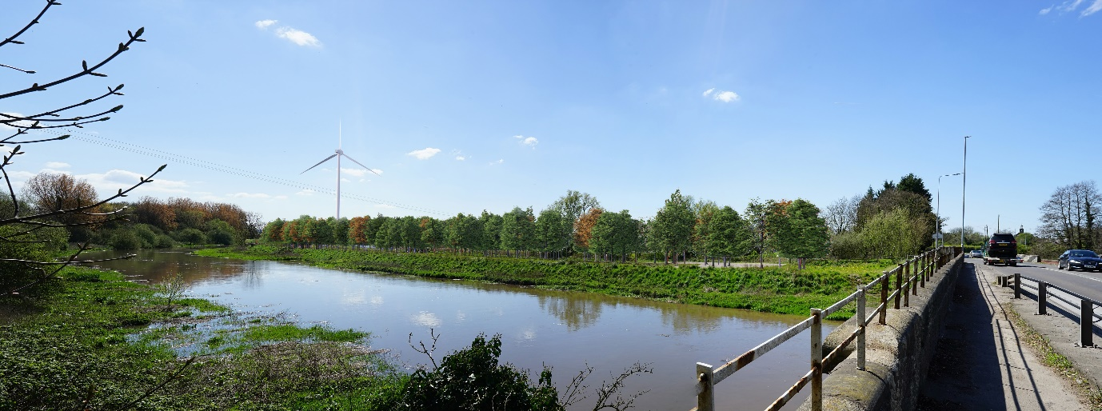

6. Assessments

The preparation of the Culture and Heritage Assessment, Acoustic Assessment, Aviation Risk Assessment and Transportation Assessment amongst others continues to be progressed. All of these assessments, when finalised, will be published on the Bretherton Energy website www.brethertonenergy.co.uk.

7. Bretherton Energy Website – www.brethertonenergy.co.uk

The format of the Bretherton Energy website has been improved to help the navigation and to give ready access to the required information. The Resource Hub tab gives access to the frequently asked questions, the bi-monthly update and all the Assessments completed.

8. Planning – National Planning Policy Framework (NPPF)

The Department for Levelling Up, Housing and Communities held a consultation on reforms to National Policy between 22nd December 2022 and 2nd March 2023. The consultation sort views on the proposals for a new Footnote 62.

The proposed changes require planning applications for on-shore wind turbines to demonstrate that “the planning impacts identified by the affected local community have been satisfactorily addressed and the proposal has community support”.

The final revised version of the NPPF is anticipated in the coming months.

9. Conclusion

Preparation of the site in terms of tree planting and improved public access are continuing, alongside the technical assessments. We continue to engage with all stakeholders through exhibitions and meeting face-to-face with residents, to inform the local community of what is proposed, in the hope of gaining their support.

GA Pet Food Partners
June 2023

